Talha Yousaf
2025-CE-93
Experiment 1 Lab 4
Explanation

Measure the current across R1, R2, R3 and Voltage between node 2 and 7.
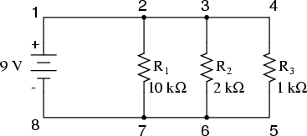
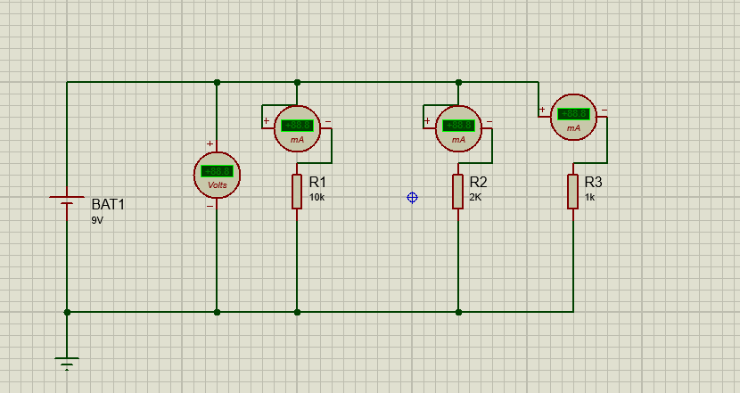
"In this circuit, I have designed a Parallel Network powered by a 9V DC source. Unlike my previous series circuits, this setup allows me to examine how current divides among different paths while the voltage remains uniform."
- My Setup: I connected three resistors—R1 (10kΩ), R2 (2kΩ), and R3$(1kΩ)—in parallel. This means each resistor is connected directly across the terminals of the battery.
- What I am Measuring:
  - DC Voltmeter: I placed this across the entire bank to confirm that each branch receives the full 9V from the source.
  - DC Ammeters: I integrated an ammeter into each individual branch. This allows me to see that the branch with the lowest resistance R3 draws the most current, while the branch with the highest resistance R1 draws the least.
Experiment 2
Measure the current across R1, R2, R3 and Voltage between node a and e.

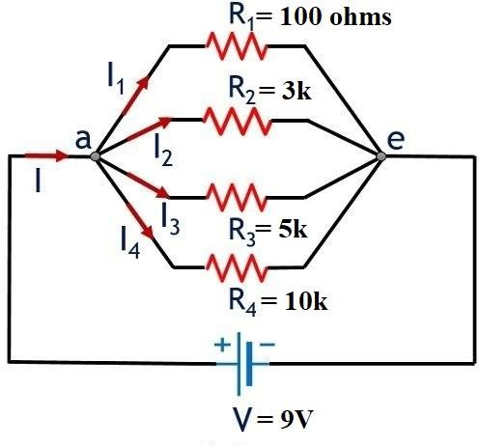
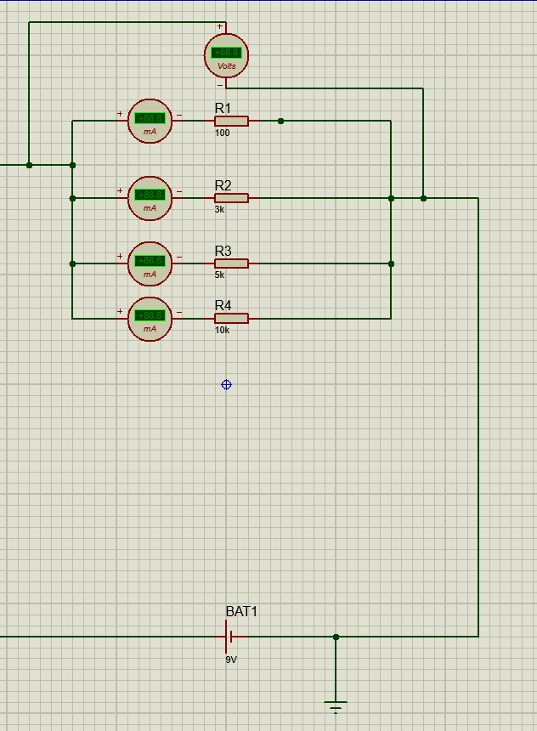

For my final circuit, I expanded the parallel concept further by building a Four-Branch Parallel Network. This configuration is a classic example of how modern household wiring works, where multiple loads operate independently of one another."
- Setup: I used a 9V battery to power four different resistors: R1 (100Ω), R2(3kΩ), R3 (5kΩ), and R4(10kΩ).
Top Voltmeter: I've placed a master voltmeter to monitor the source voltage being applied to the parallel grid.

Branch Ammeters: I have placed an ammeter in series with every single resistor. This setup clearly illustrates that in a parallel circuit, $I = V/R$ applies individually to each path.

